Gap and No-Gap Explanation :

Steps to Replicate :

1. Navigate to the GDPR Application Tracker in UAT and PROD Instance.

Ex: GBS/IT VP Tracker. Make Sure the Filters are same between UAT and PROD instance.

1. Click on the Gap Application and verify the records in Application Details.
2. Compare the UAT and PROD reports.
3. Verify the applications where Gap in UAT instance and Not a Gap in PROD instance.
4. Validation is done in consolidated report.

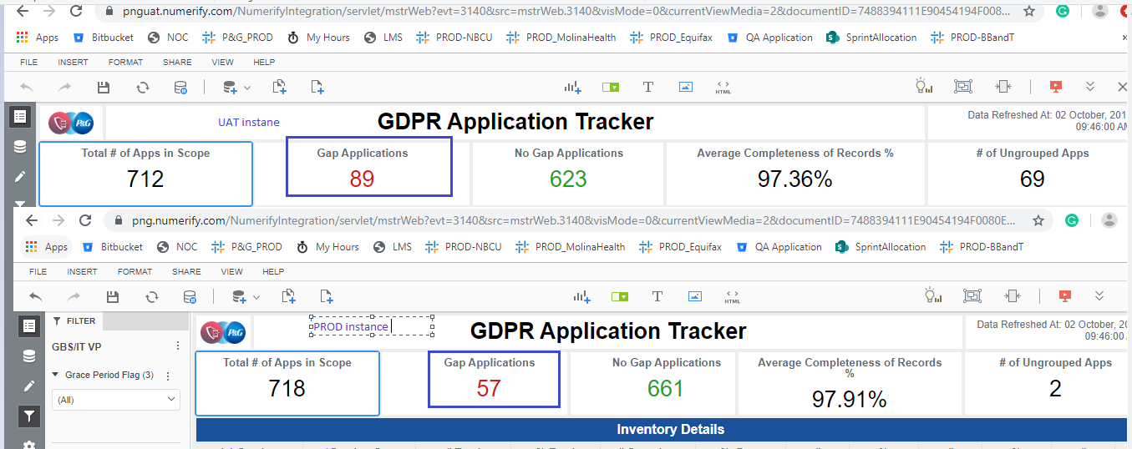

UAT instance:

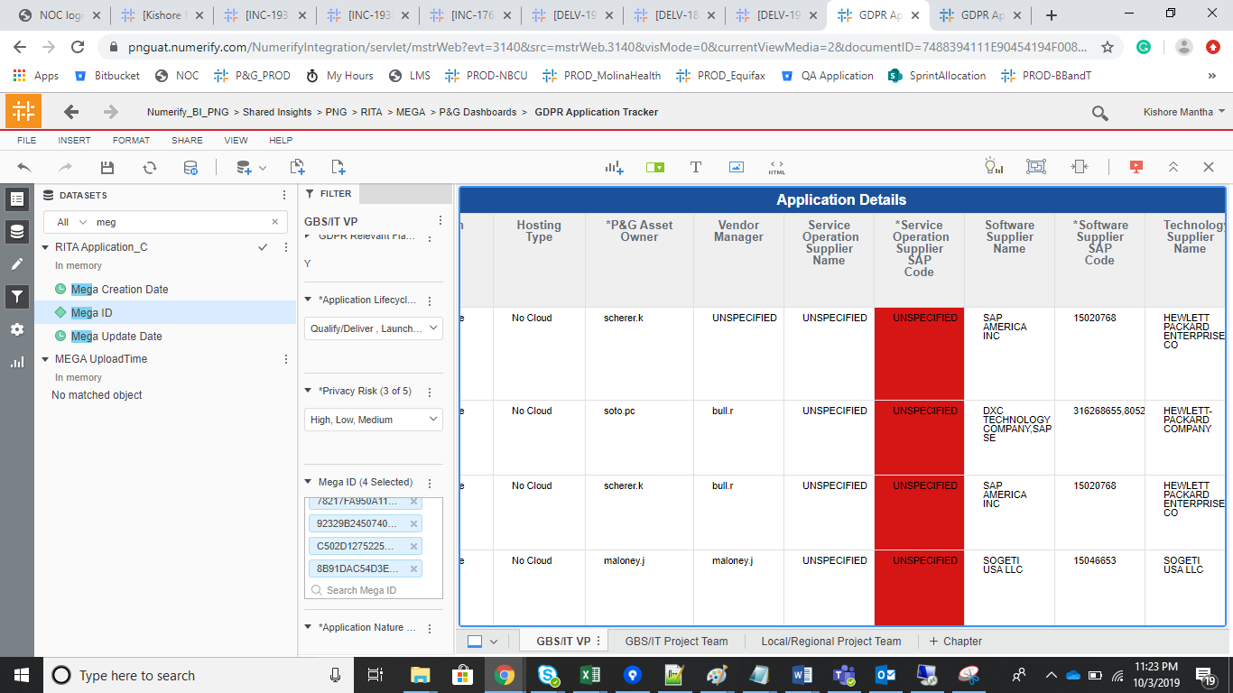

2. Grouping and Un grouping.

One of the attribute used for deriving the Grouping logic is u_authentication_authorization_pii_only where as Yes or No in Mega, But in Service now , most of the application are moved to UNSPECIFILED.

Ex:

00BC0CE757FD7C58

08900CEF4A2E066E

0BC116BF509F4682

0C97122A5BA95C9E

0CF4388B5A5E6E96

0D92236559A549A9

10B524544D1C04E5

12DD48935AD724CE

1A142BFB581C5574

1ACE1F2E53F212E0

UAT Instance grouping logic

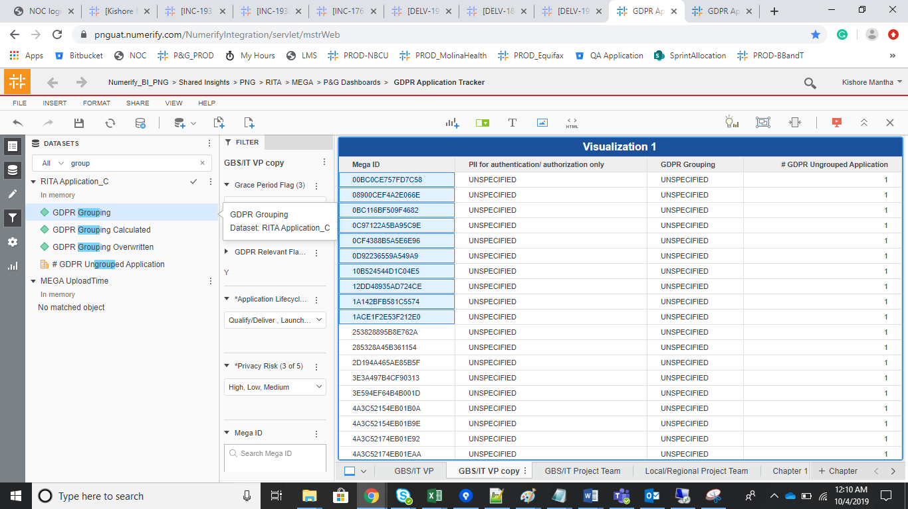

Prod instance :

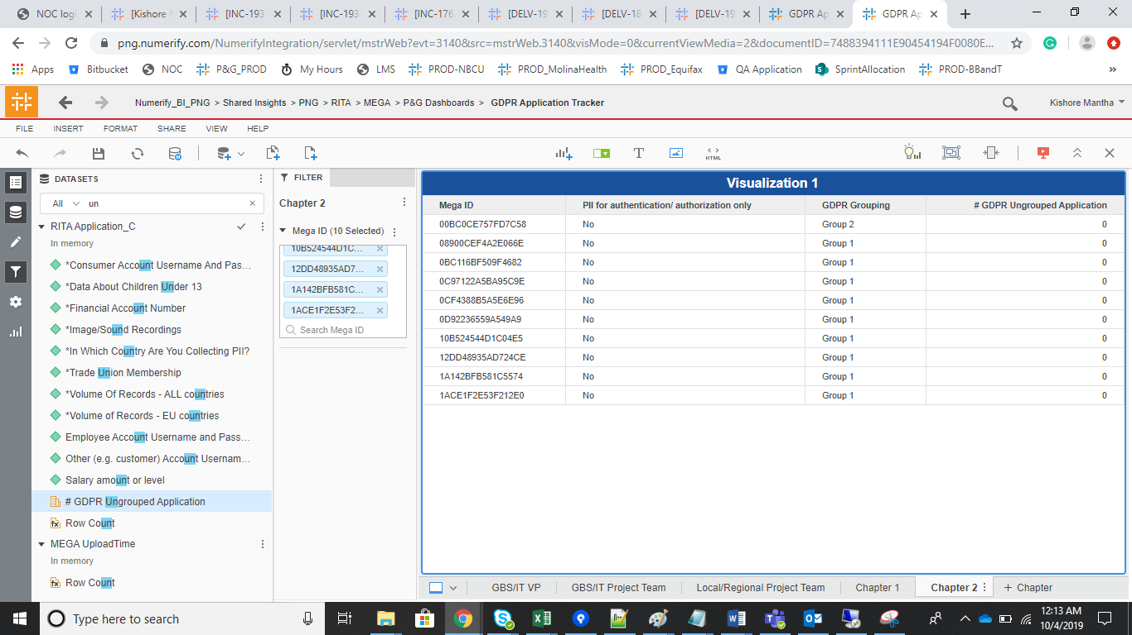

Query :

Select u_authentication_authorization_pii_only,Count(1) as CNT FROM png_mdsdb.cmdb_ci_appl_final a

where a.sys_class_name='cmdb_ci_appl'

group by 1;

